SIMATS ENGINEERING
ASSESSMENT TOOL 1
Course: Object Oriented Analysis and Design (CSA1110)
CO2: Design UML diagrams to represent system requirements and architecture (BL3)
Section: Annexure A — Analytical Problem Solving | Answered: Questions 1, 2, 3 & 4 (Any 4, 10 marks each)

Question 1 — Use Case Diagram: Hospital Management System
Scenario: A Hospital Management System allows patients to book appointments, doctors to update medical records, and administrators to manage hospital resources.

a) Actors Identified
- Patient (Primary actor) — books/cancels appointments, views own medical records, makes payments.
- Doctor (Primary actor) — views and updates patients' medical records.
- Administrator (Primary actor) — manages hospital resources and generates reports.
- Staff (Abstract actor) — generalization of Doctor and Administrator; both share login behaviour.
- Payment Gateway (Secondary/external actor) — external system that processes online payments.

b) Primary Use Cases
- Login
- Book Appointment
- Cancel Appointment
- View Medical Records
- Update Medical Records
- Make Payment
- Manage Hospital Resources
- Generate Reports

c) Relationships
- <<include>>: "Book Appointment" includes "Login" — a patient must be authenticated before booking (mandatory sub-behaviour).
- <<include>>: "Make Payment" includes "Login" — payment requires an authenticated session.
- <<extend>>: "Cancel Appointment" extends "Book Appointment" — cancellation is an optional flow that only occurs under a specific condition.
- Generalization: "Doctor" and "Administrator" generalize from "Staff" — both inherit common login/authentication behaviour.
- Association: each actor connects to the use cases it directly initiates (Patient–Book Appointment, Doctor–Update Medical Records, Administrator–Manage Hospital Resources, etc.).

d) Use Case Diagram
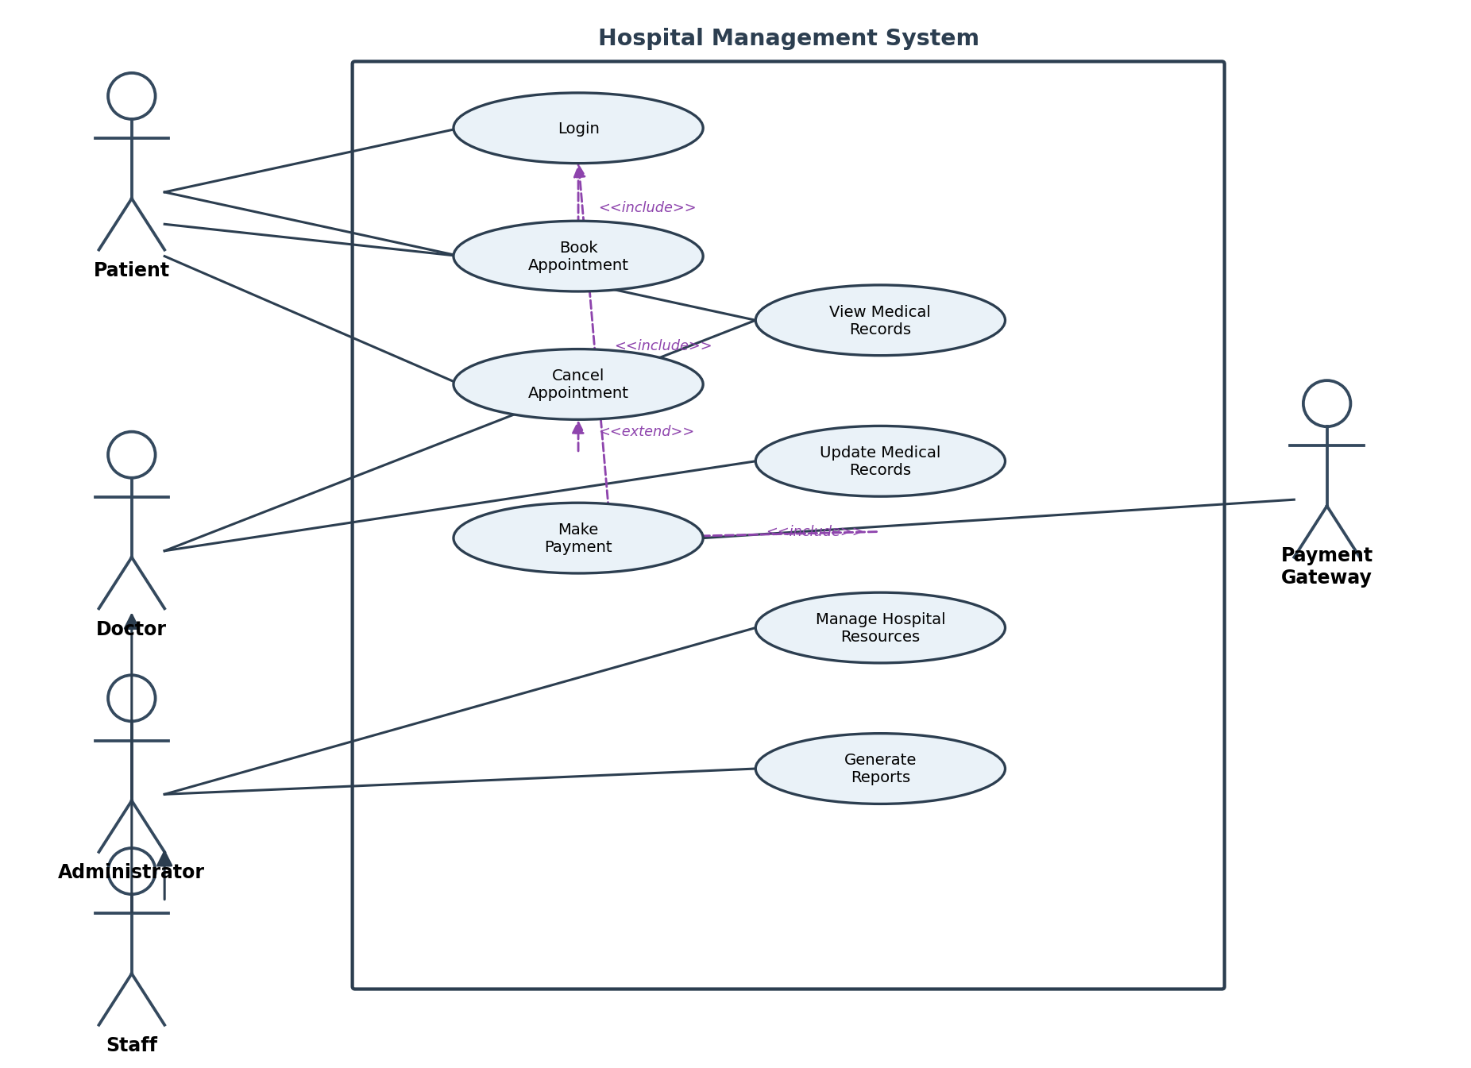
Figure 1: Use Case Diagram — Hospital Management System

Question 2 — Class Diagram: Library Management System
Scenario: A Library Management System contains entities such as Book, Member, Librarian, and IssueRecord.

a) Classes with Attributes and Methods
Class | Attributes | Methods
Person (abstract base) | id, name, email | login()
Member | memberID, phone, membershipDate | searchBook(), requestBook(), viewHistory()
Librarian | staffID, designation | issueBook(), receiveBook(), registerMember()
Book | bookID, title, author, isbn, status | checkAvailability(), updateStatus()
IssueRecord | issueID, issueDate, dueDate, returnDate | calculateFine(), closeRecord()

b) Relationships
- Inheritance (Generalization): Member and Librarian both generalize from an abstract Person class, since both share id, name and login().
- Association: Member borrows via IssueRecord; Librarian processes IssueRecord entries.
- Association: IssueRecord refers to one Book at a time.
- (Optional extension) Aggregation could be added between a Library class and Book, since Books exist independently of the Library object.

c) Multiplicity
- Member (1) — IssueRecord (0..*): a member can have zero or many issue records over time; each record belongs to exactly one member.
- Librarian (1) — IssueRecord (0..*): a librarian can process many issue transactions.
- Book (1) — IssueRecord (0..*): a book can appear in many issue records across its lifetime; each record refers to exactly one book.

d) Class Diagram
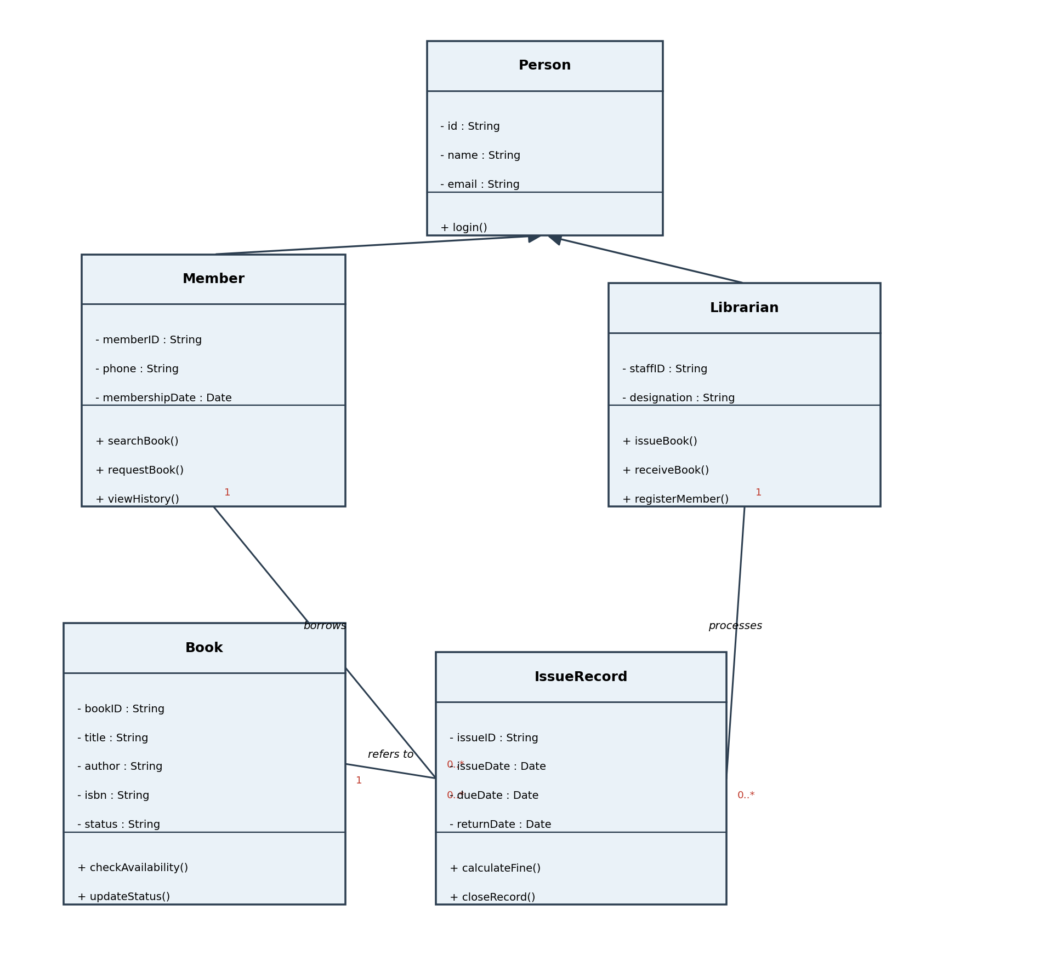
Figure 2: Class Diagram — Library Management System

Question 3 — Sequence Diagram: Online Food Ordering System
Scenario: A customer selects food items, places an order, makes payment, and receives order confirmation.

a) Objects (Lifelines) Involved
- Customer — the actor initiating the interaction.
- OrderUI — the front-end interface the customer interacts with.
- OrderController — back-end controller coordinating the order workflow.
- PaymentGateway — external service that authorizes and processes payment.
- Kitchen — receives and accepts the confirmed order for preparation.
- NotificationService — sends confirmation notifications back to the customer.

b) Message Flow Between Objects
- Customer → OrderUI: selectFoodItems(), placeOrder()
- OrderUI → OrderController: createOrder(items); returns orderID
- OrderUI → OrderController: initiatePayment(orderID)
- OrderController → PaymentGateway: processPayment(amount)
- PaymentGateway --> OrderController: paymentConfirmation() (return message, dashed)
- OrderController → Kitchen: sendToKitchen(orderID)
- Kitchen --> OrderController: orderAccepted() (return message, dashed)
- OrderController → NotificationService: notifyCustomer(orderID)
- NotificationService --> Customer: orderConfirmation (dashed)
- OrderController --> OrderUI --> Customer: confirmOrder() / displayConfirmation() (dashed returns)

c) Activation Bars and Lifelines
- Each object has a vertical dashed lifeline running down the diagram, representing its existence over time.
- A rectangular activation bar is shown on a lifeline while that object is actively executing — e.g. OrderController remains active from order creation through to sending the final confirmation.
- Solid arrows with filled heads represent synchronous request/call messages; dashed arrows represent return messages sent back to the caller.

d) Sequence Diagram
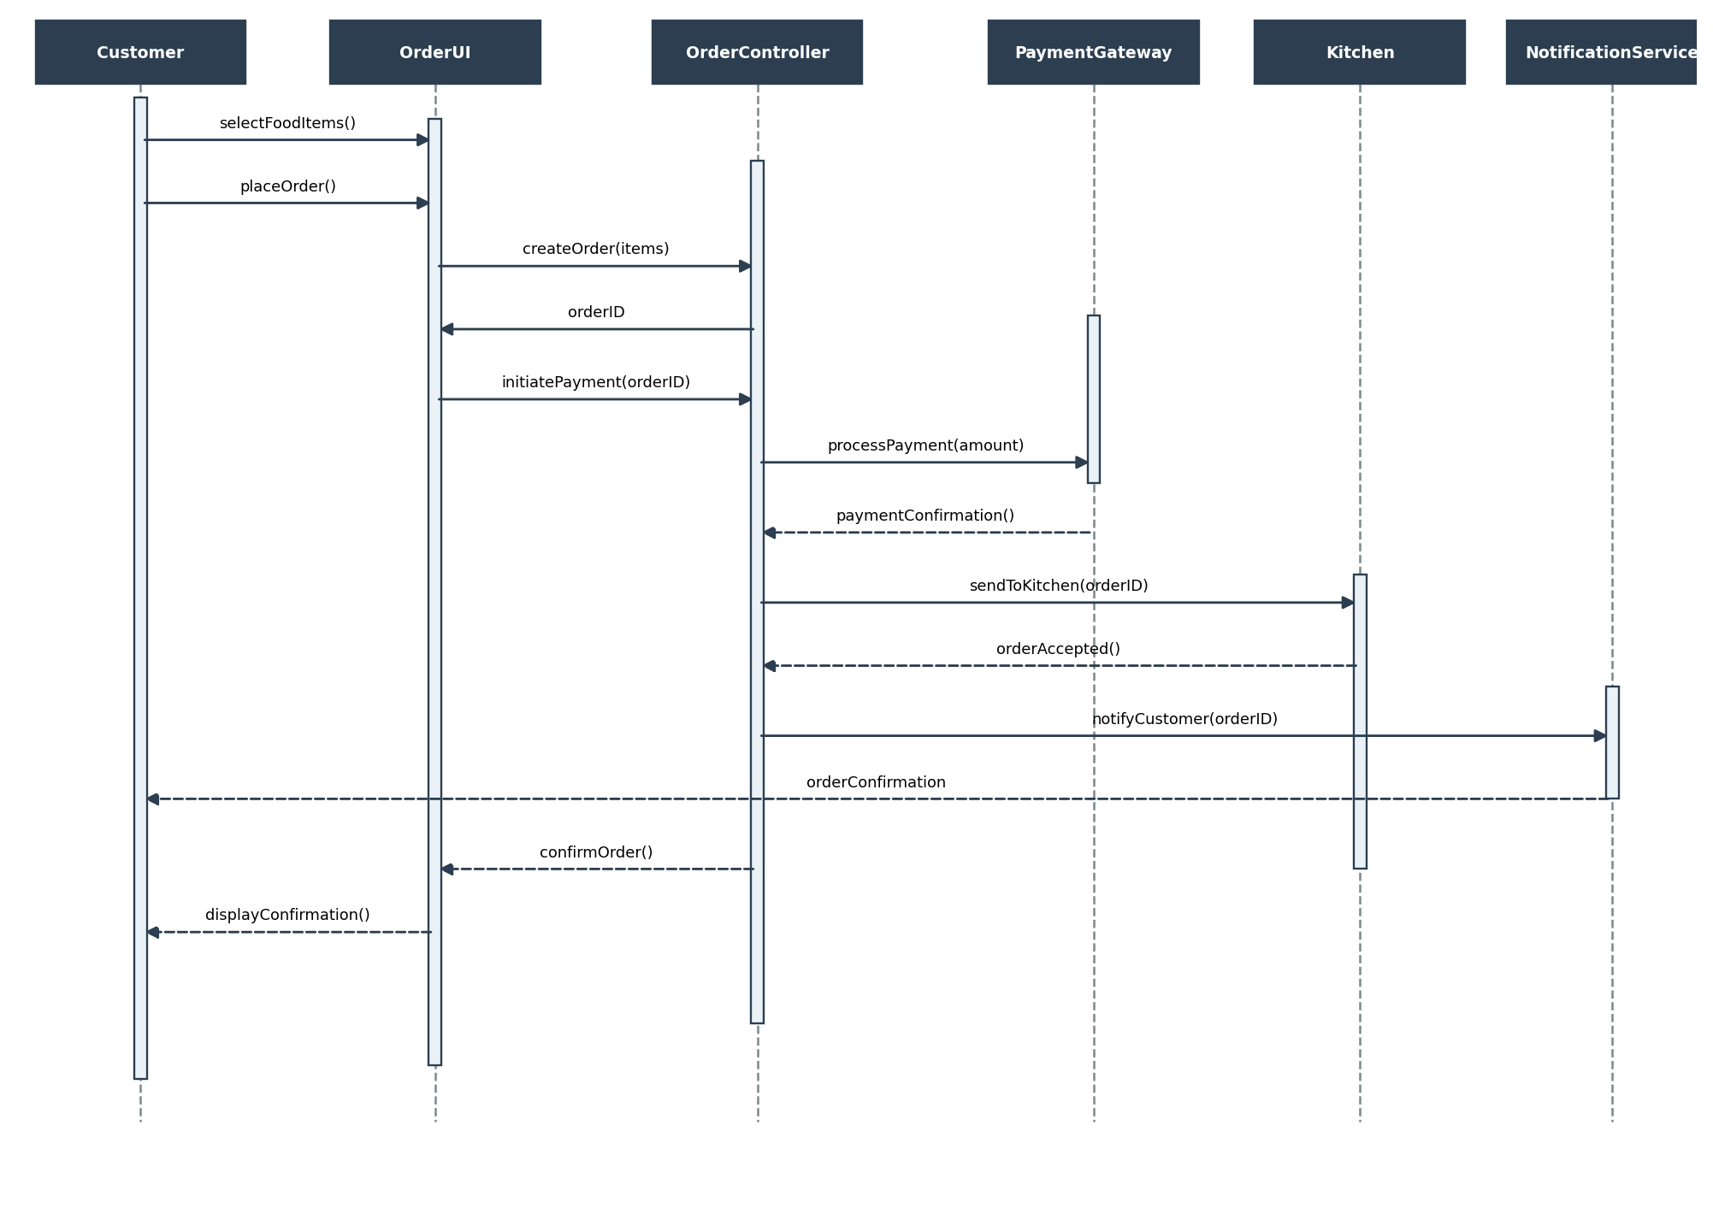
Figure 3: Sequence Diagram — Online Food Ordering System

Question 4 — Activity Diagram: Student Admission System
Scenario: A Student Admission System includes application submission, document verification, fee payment, and enrollment confirmation.

a) Activities in the Workflow
- Fill Application Form
- Submit Application
- Verify Documents
- Pay Admission Fee
- Confirm Enrollment
- Send Welcome Email (parallel)
- Generate Student ID Card (parallel)
- Update Admission Records

b) Decision Nodes
- Documents Valid? — [Yes] proceeds to fee payment; [No] routes to "Reject Application & Notify Applicant" and the flow terminates.
- Payment Successful? — [Yes] proceeds to "Confirm Enrollment"; [No] routes to "Notify Payment Failure" and the flow terminates.

c) Parallel Processing
- After enrollment is confirmed, a fork bar splits the flow into two concurrent activities: "Send Welcome Email" and "Generate Student ID Card".
- A join bar synchronizes both branches before the workflow proceeds to "Update Admission Records", ensuring both tasks complete before final processing.

d) Activity Diagram
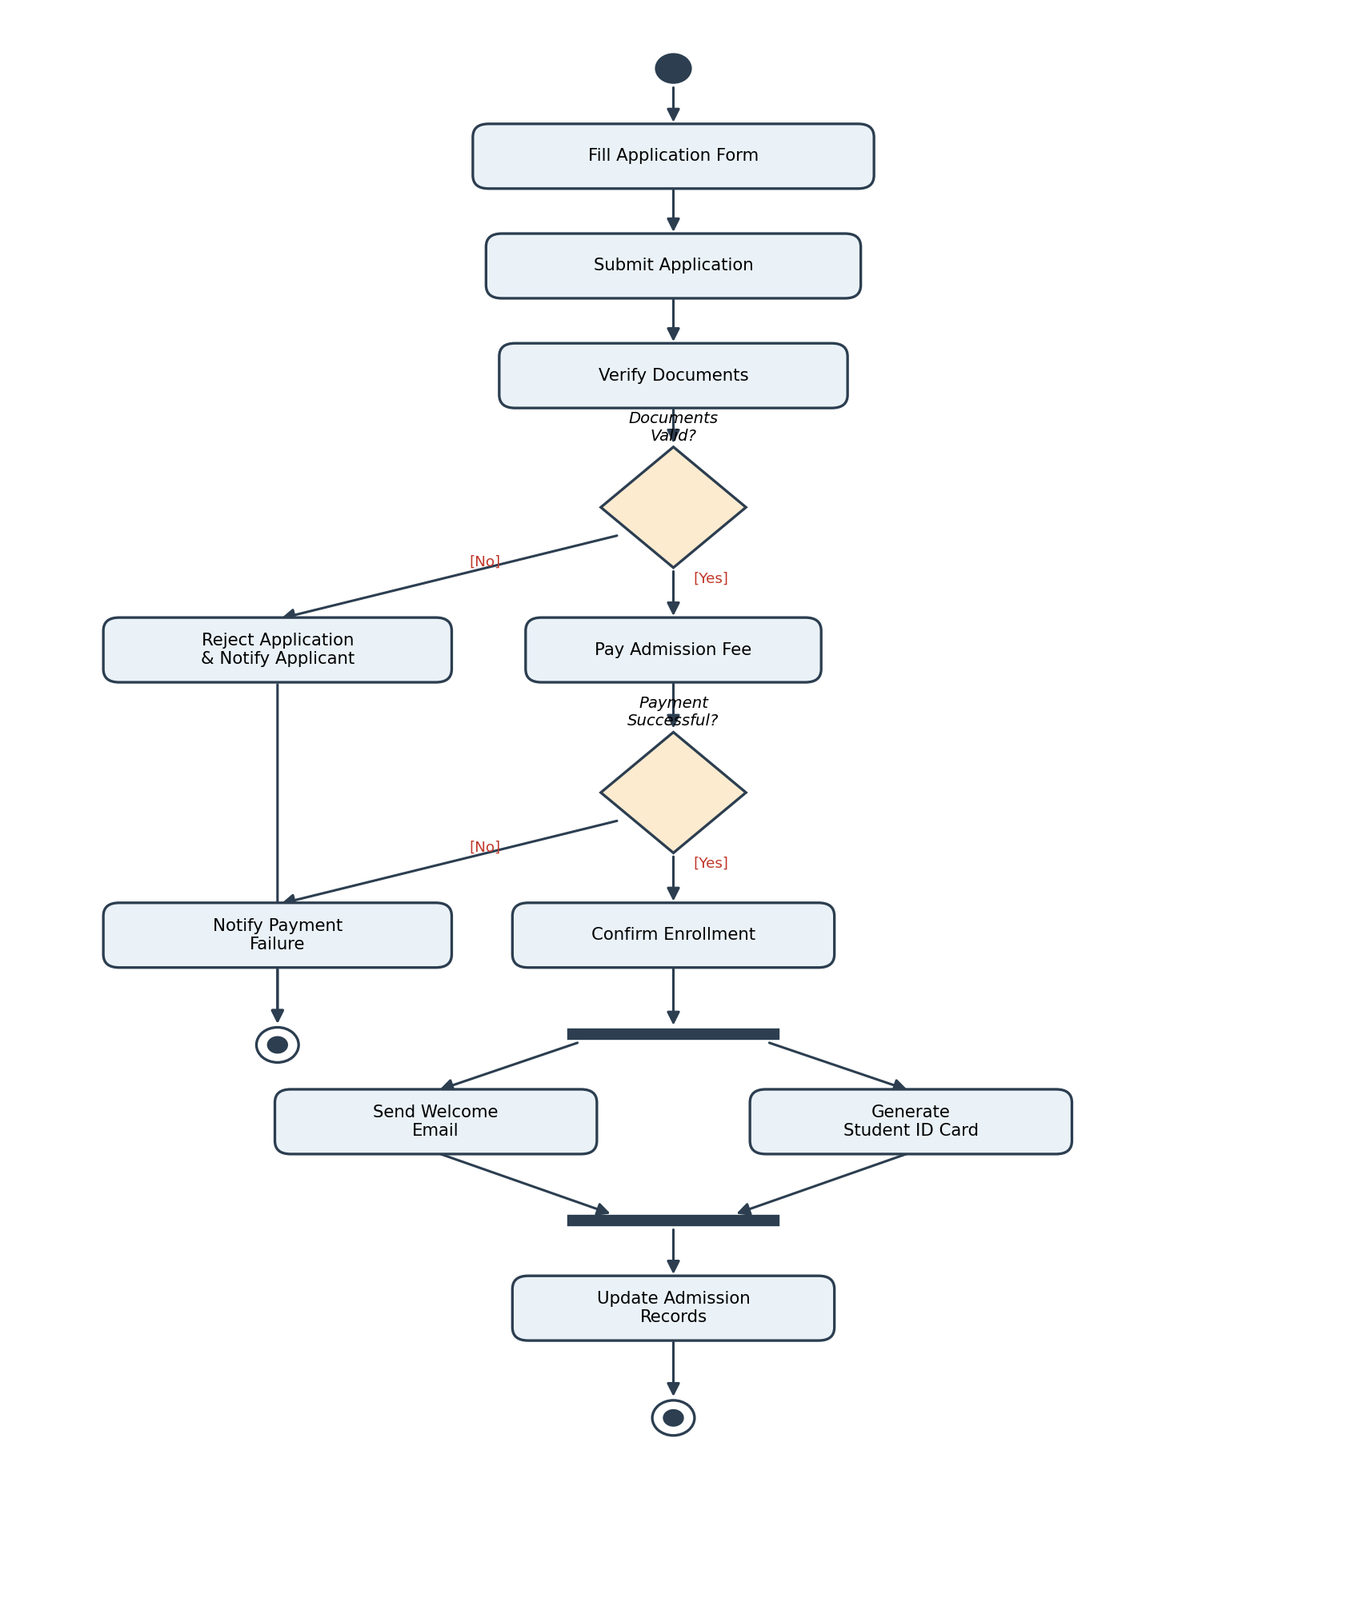
Figure 4: Activity Diagram — Student Admission System

